Q2. unpack part (c) step by step, make sense of the reasoning, and learn how to approach similar questions in an exam.

Understanding the scenario
We have:
- A relation R(A, B, C) in secondary storage.
- We need to sort it by attribute A.
- Instead of sorting entire tuples (which are large), we sort only <key, record pointer> pairs.
- The record pointer points to the tuple’s original location in R.
- Later, we use those pointers to reconstruct the sorted relation.
The advantage?
Sorting smaller items (<key, pointer> pairs) means:
- Less I/O in the sorting phase (because fewer blocks are moved around).
- But extra I/O is needed later to retrieve the full tuples in sorted order.

Step-by-step solution breakdown

1. Size of a record
We already calculated in the question:
Record header = 28 bytes
A = 32 bytes
B = 200 bytes
C = 140 bytes
Total = 28 + 32 + 200 + 140 = 400 bytes per record
Block size = 4096 bytes
Block header = 60 bytes
Available for records = 4096 − 60 = 4036 bytes
Unspanned storage means a record cannot be split across blocks.
So:
Records per block = floor(4036 / 400) = 10
Blocks needed = ceil(100000 / 10) = 10000 blocks
This confirms R is stored in 10000 blocks.

2. Size of <key, pointer> pair
- Key (A) = 32 bytes
- Record pointer = 8 bytes
Total = 40 bytes per pair
Available for pairs = 4096 − 60 = 4036 bytes
Pairs per block = floor(4036 / 40) = 100
Blocks needed for all pairs = ceil(100000 / 100) = 1000 blocks
So key-pointer pairs take 1000 blocks instead of 10000.

3. I/O cost steps
Here’s what happens in the variant algorithm:

Step 1 — Read relation & create key-pointer pairs
We must read the original relation once to extract <A, pointer> for each tuple:
Read R: 10000 I/Os

Step 2 — Sort phase: write sorted runs of key-pointer pairs
We store the <key, pointer> pairs in blocks (100 per block) and write the runs:
Write key-pointer pairs: 1000 I/Os

Step 3 — Merge phase: read sorted runs
We now read those sorted runs back:
Read key-pointer pairs: 1000 I/Os

Step 4 — Retrieve actual tuples
For each pointer, we go to the original R and fetch the tuple.
If no clever block-based retrieval is done (worst case), each fetch is 1 I/O per tuple:
Retrieve tuples: 100000 I/Os

Step 5 — Write sorted relation
We now store the fully sorted relation back to disk:
Write sorted R: 10000 I/Os

4. Total I/O cost
Add them up:
Read relation = 10000
Write sorted runs of kpp = 1000
Read sorted runs of kpp = 1000
Retrieve tuples = 100000
Write sorted relation = 10000
-----------------------------------------
Total = 122000 I/Os

Key exam concepts here
- Unspanned storage
  - Records are not split across blocks, so floor() is used when calculating records per block.

- Key-pointer sorting
  - When sorting <key, pointer> pairs, the file size is smaller → sorting cost is lower.
  - But retrieving tuples later can be expensive.
- I/O cost breakdown
Always split into:
  - Read original data
  - Write runs
  - Read runs
  - Fetch full tuples
  - Write sorted data
- Pointer retrieval cost
  - Worst-case: 1 I/O per tuple (if each is on a different block and not cached).
  - Best-case (if grouped by block): far fewer I/Os.

✅ Exam tip for similar problems:
- Step 1: Compute record size → blocks for original relation.
- Step 2: Compute key-pointer pair size → blocks for sorting phase.
- Step 3: Lay out all steps of the algorithm in order and calculate I/Os for each.
- Step 4: Be explicit about worst-case vs. best-case retrieval when using pointers.

Alright — here’s a clear diagram of the key-pointer sorting process for part (c).

📊 Key-Pointer Sorting Flow (Variant of 2-Pass Sort)
Step 1: Read Original Relation R
---------------------------------
[ Disk: R in 10000 blocks ]
↓ (read 10000 I/Os)
Extract <Key, Pointer> for each tuple
Store in memory as: <A-value, pointer-to-tuple>

Step 2: Write Sorted Runs of KPP
---------------------------------
[ Memory: sorted chunks of KPP ]
↓ (write 1000 I/Os)
[ Disk: sorted runs of key-pointer pairs ]

Step 3: Merge Sorted KPP Runs
------------------------------
[ Disk: sorted runs of KPP ]
↓ (read 1000 I/Os)
Merge in memory into single sorted KPP list

Step 4: Retrieve Tuples via Pointers
-------------------------------------
For each pointer in sorted list:
→ Go to original R and fetch the full tuple
(100000 I/Os worst-case)

Step 5: Write Final Sorted Relation
------------------------------------
[ Memory: sorted full tuples ]
↓ (write 10000 I/Os)
[ Disk: R sorted by A ]

💡 Memory Hook for Exams:
Think of it as “Small Sort First, Big Fetch Later”:
- First, shuffle only tiny address cards (<key, pointer> pairs).
- Then, once in order, pull the full items (tuples) from storage.
- The benefit is smaller sorting cost (Step 2 & 3),
but the penalty is big retrieval cost (Step 4).

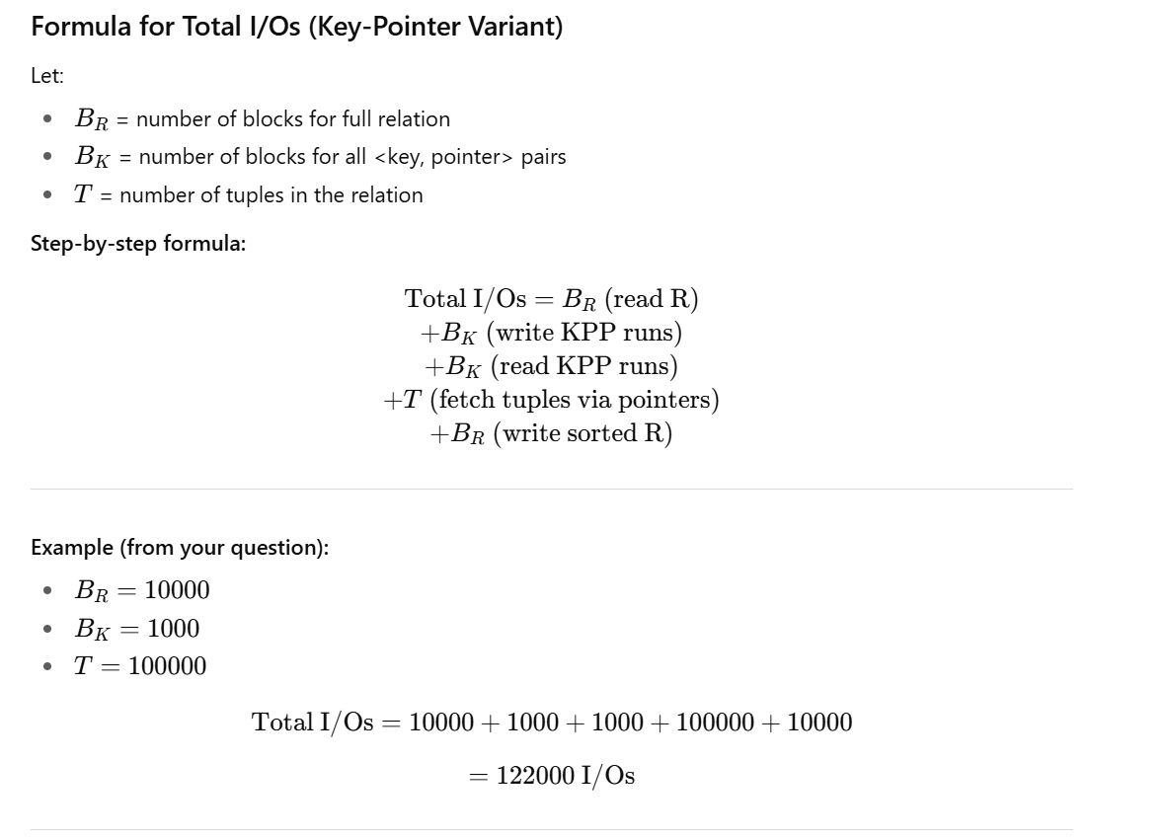
✅ Why this works in an exam:
- Only 3 things you must compute: B_R​, B_K​, and T.
- Plug into formula → done in under 1 minute.

📄 Sorting in External Memory – Quick Exam Cheat Sheet

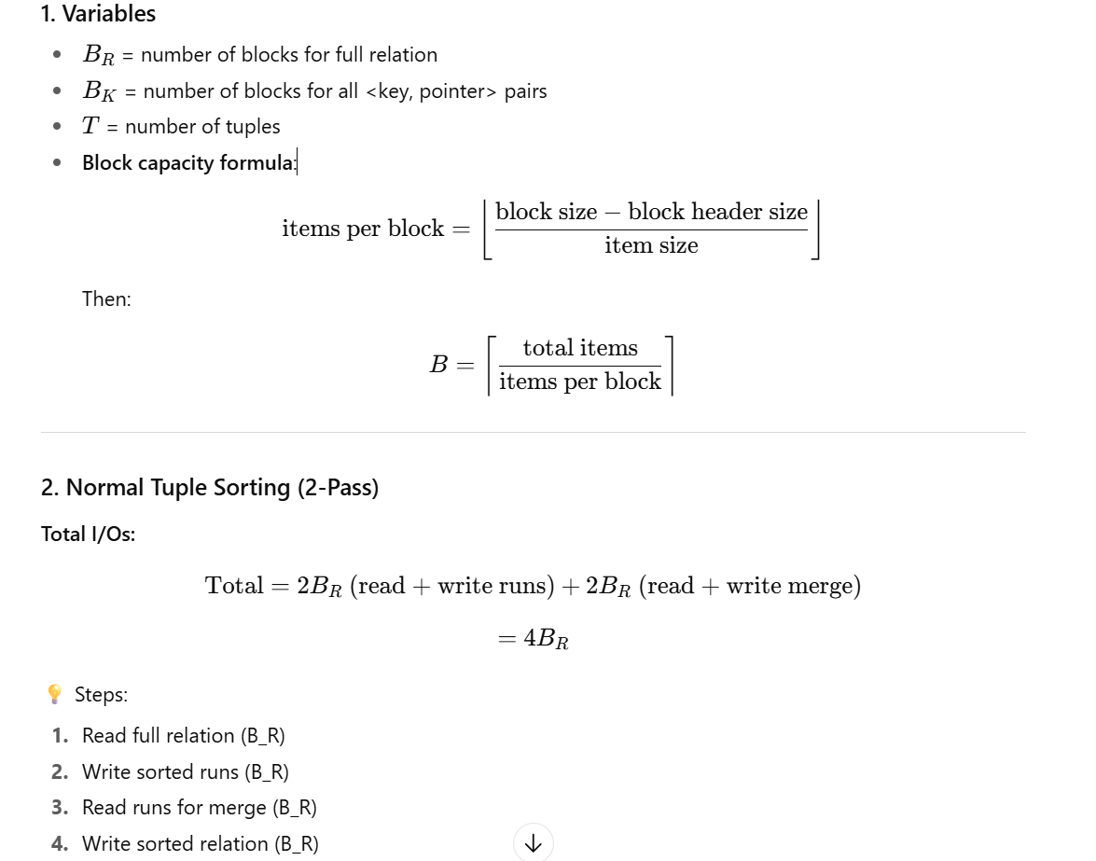
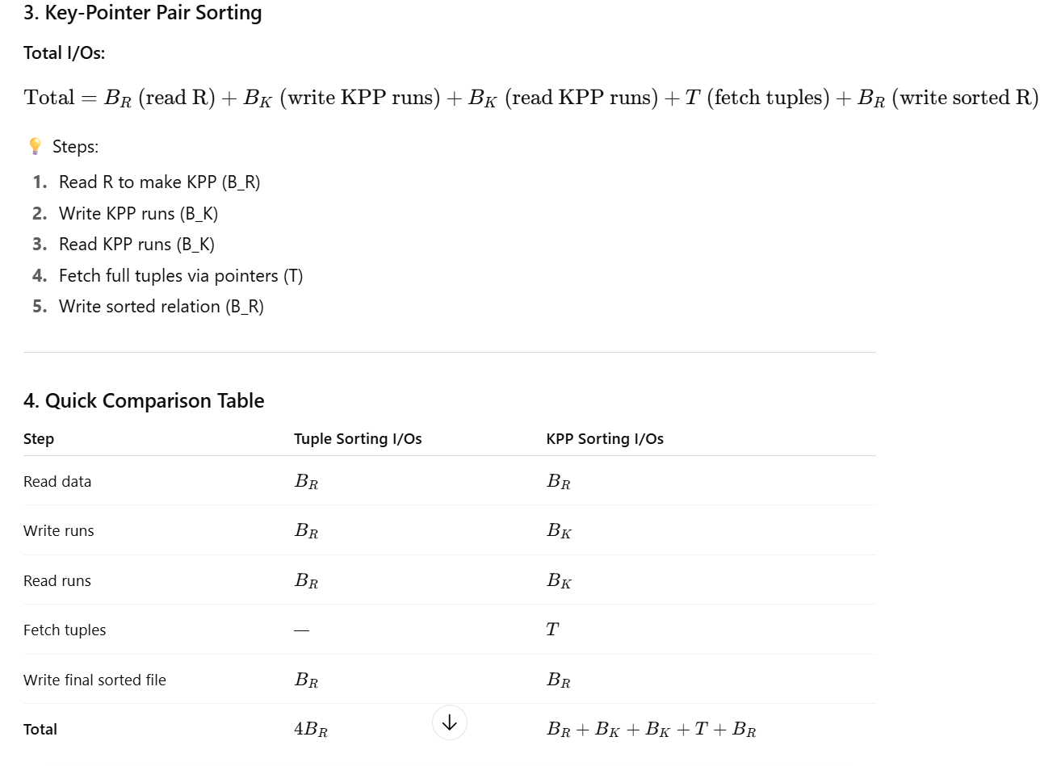

✅ Exam Shortcut:
- If tuples are big, B_K ≪ B_R ​, so sorting KPP is much cheaper in sorting phase.
- But pointer retrieval step (T I/Os worst-case) can dominate cost.

